**CREATING CLARITY USER AND ASSIGINING DEFAULT ROLES**

1. **Checking the details of user to be replicated**

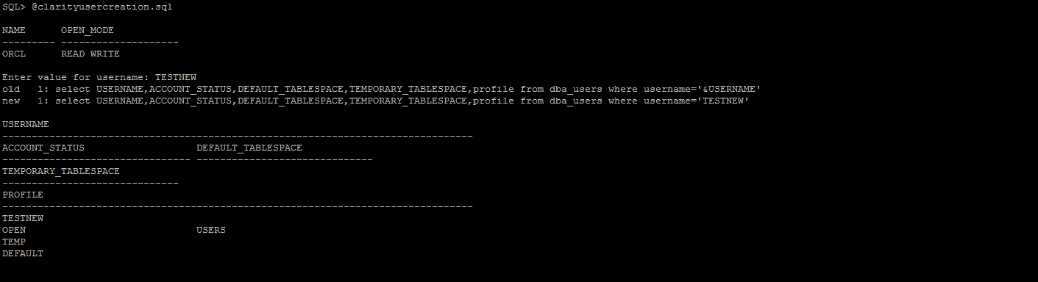

1. **User creation**

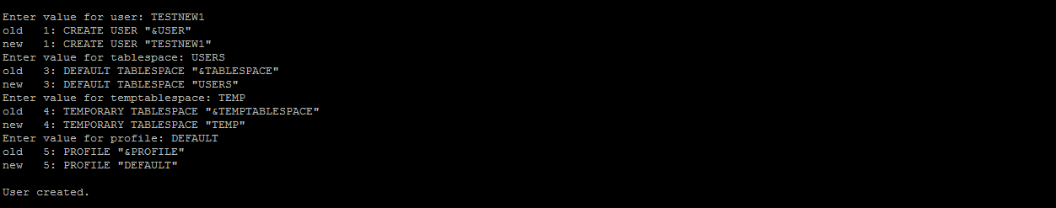

1. **Assigning roles to the new user created.**



1. **Checking the status of the new user created.**



